**P2 - Sustainable Supply Chain Performance Dashboard using**

**Power BI**

**WEEK 1 ASSIGNMENT**

**Steps to import and create tables using .CSV for Data Analysis using Power BI**

**Step 1: Open power BI and import you .CSV file**

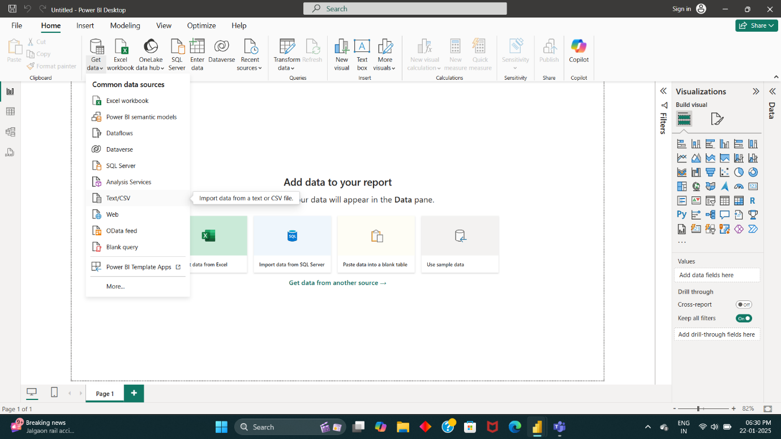

**Step 2: Choose .csv file and click upload**

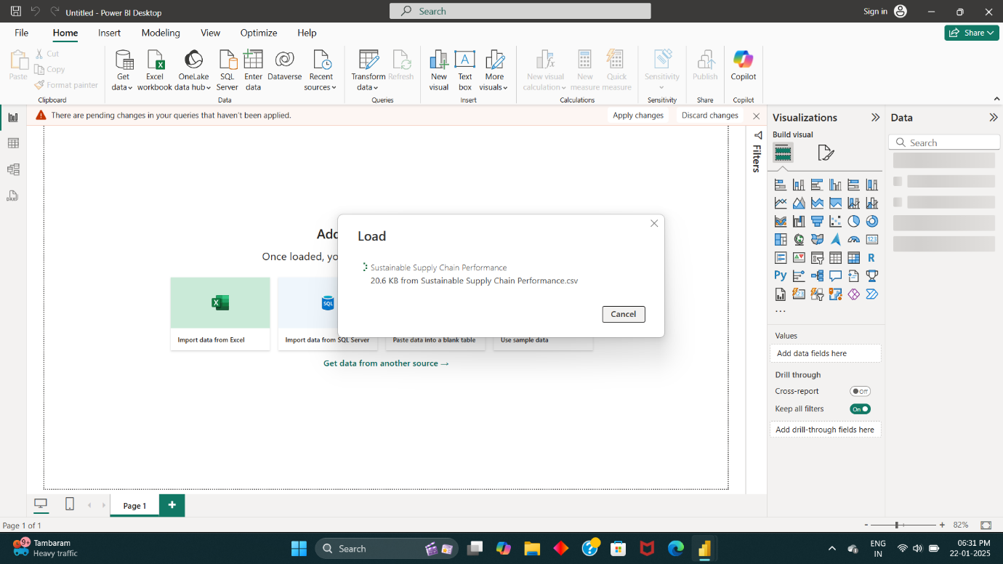

**Step 3: Loaded table**

The .CSV file will be imported and the table will be displayed in the right side of the home page in Data Region.

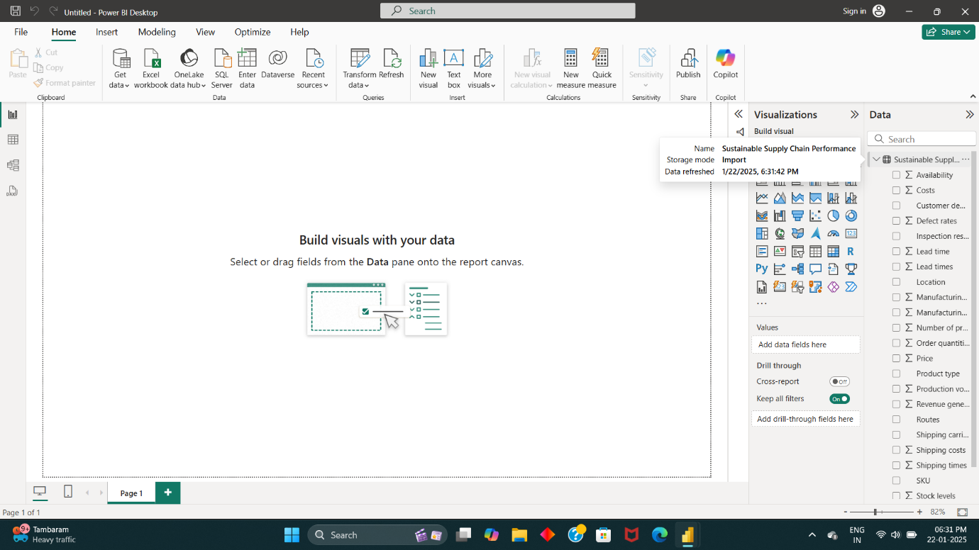

**Step 4: Transforming Data**

* In the Tools panel of the home page navigate to Transform Data

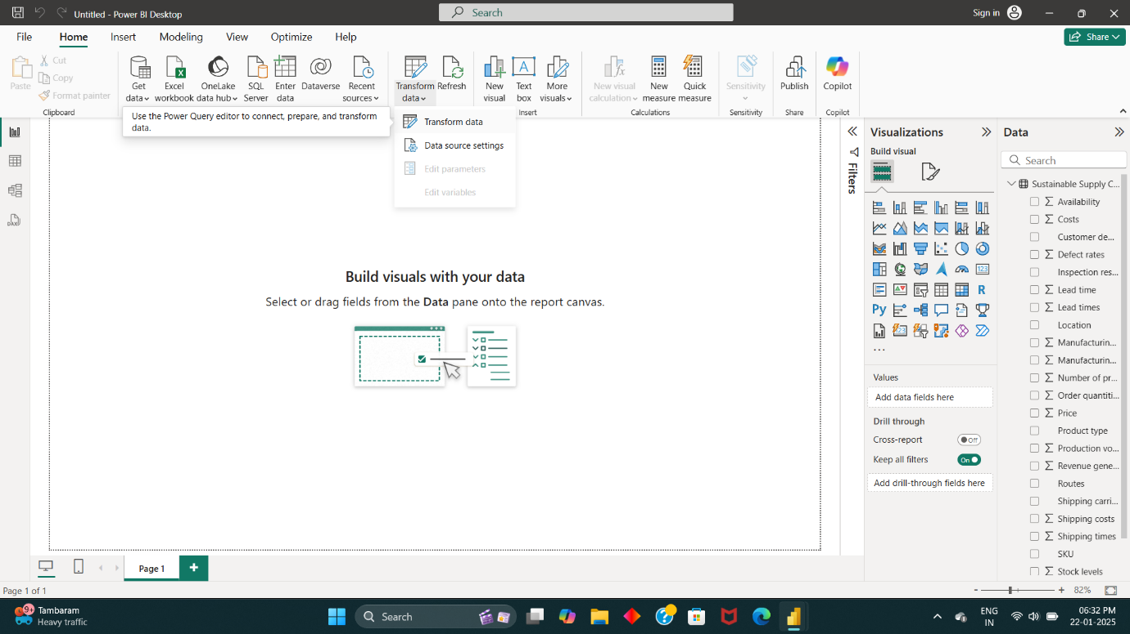

* The Transform Data navigation will redirect to **Power Query Editor** panel
* In Power Query Editor, The Table will be displayed in **Rows and Columns**
* Now In Query region (left-end-side), **Right Click** on the Existing table name and click **Duplicate**

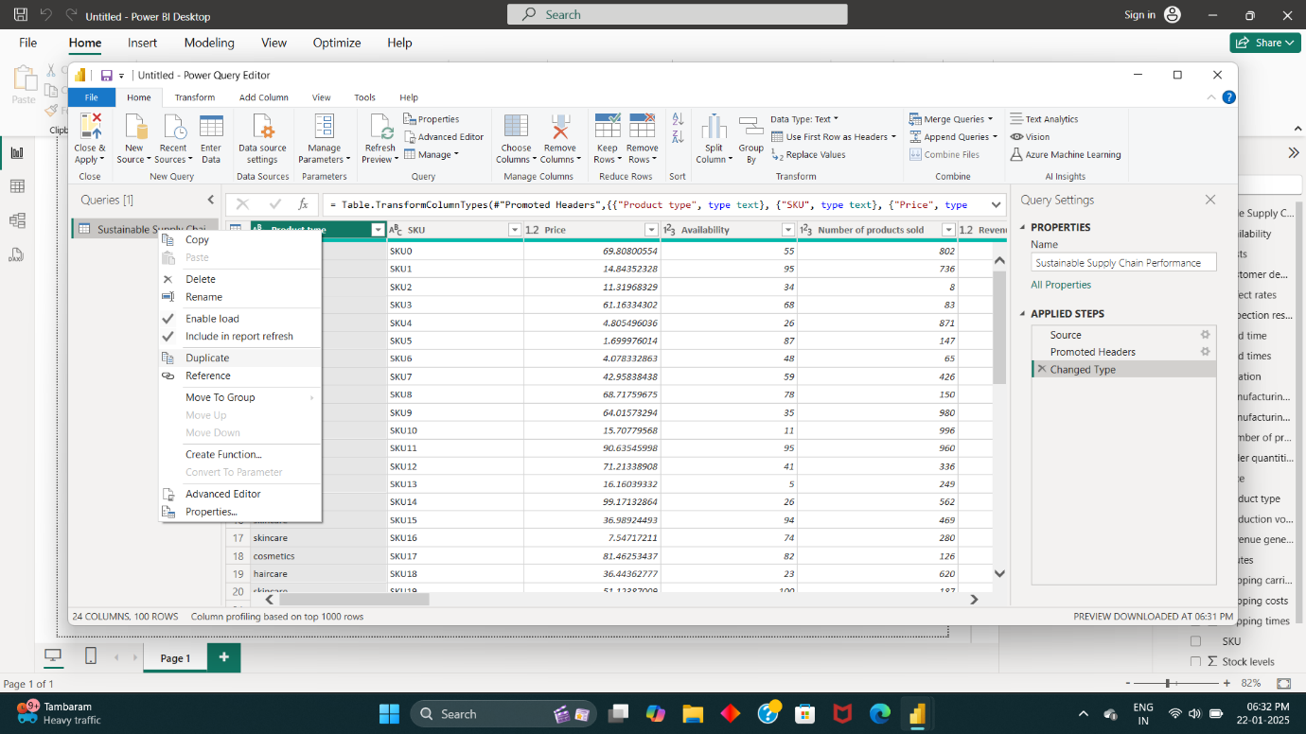

**Step 5: Create Duplicate Tables**

* Create different tables in names of **manufacturing, supplier, inventory, supply chain** by Duplicating the Existing Table.
* Remove Unnecessary Columns which not related to each table.

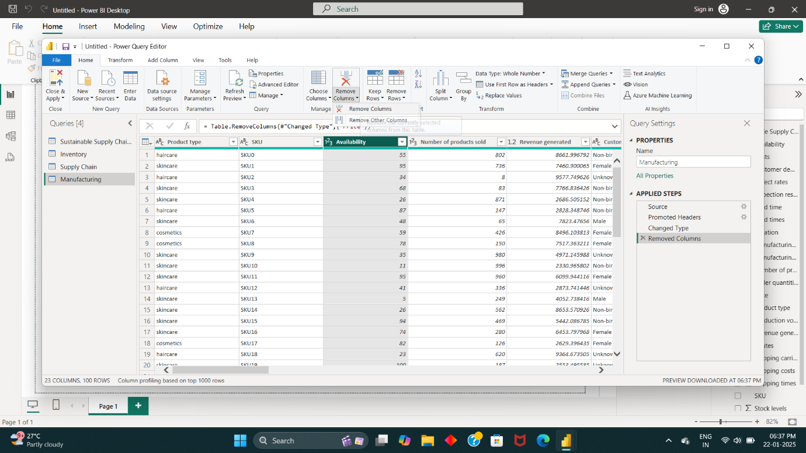

**Step 6: Save the Transformed Table Data**

* After transforming the data, click on **Close & Apply** in top left tool bar.

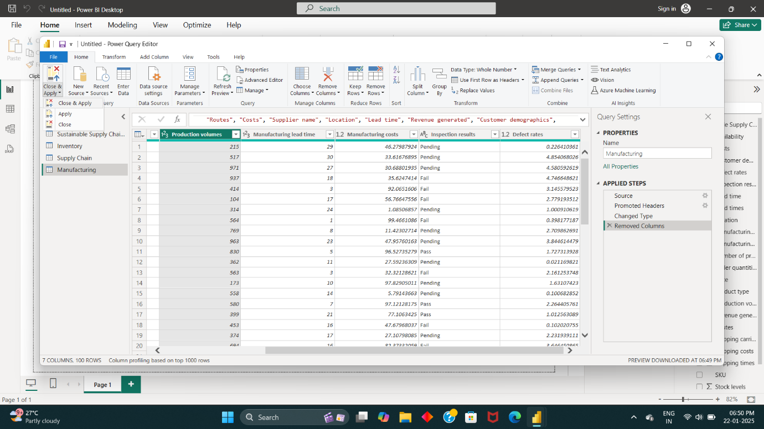

**Step 7: Table data are Ready for analysis**

* Now you can view the list of tables and Attributes in Data Region

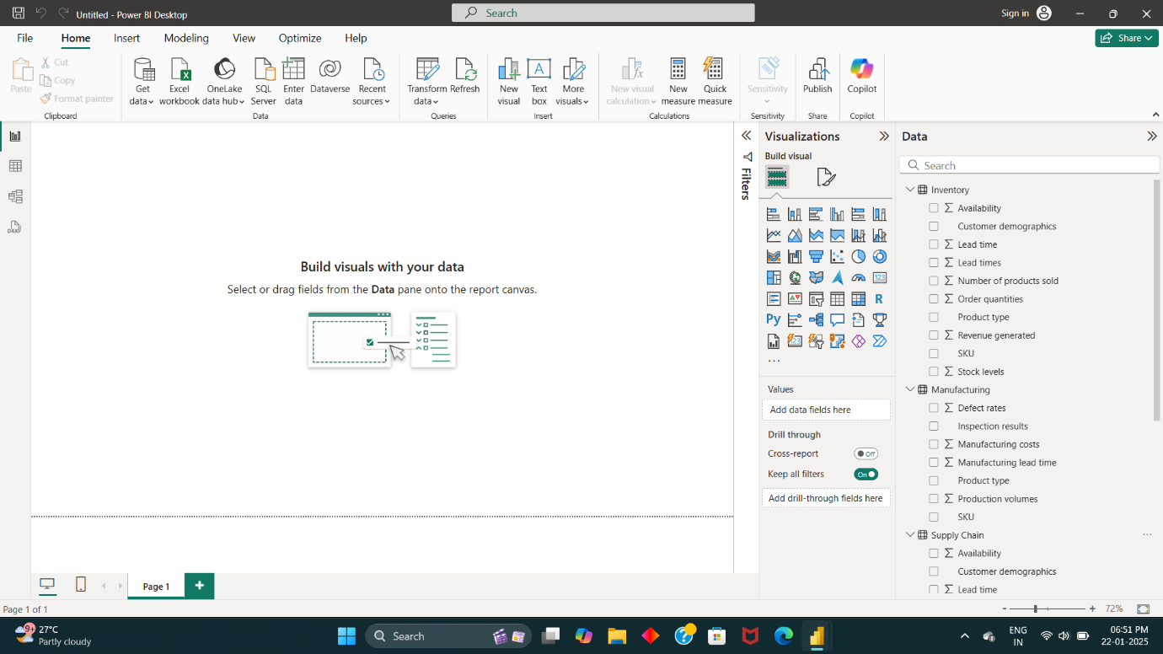

* In **Model View**, we can able to view how each **attribute** correlated to each **tables.**

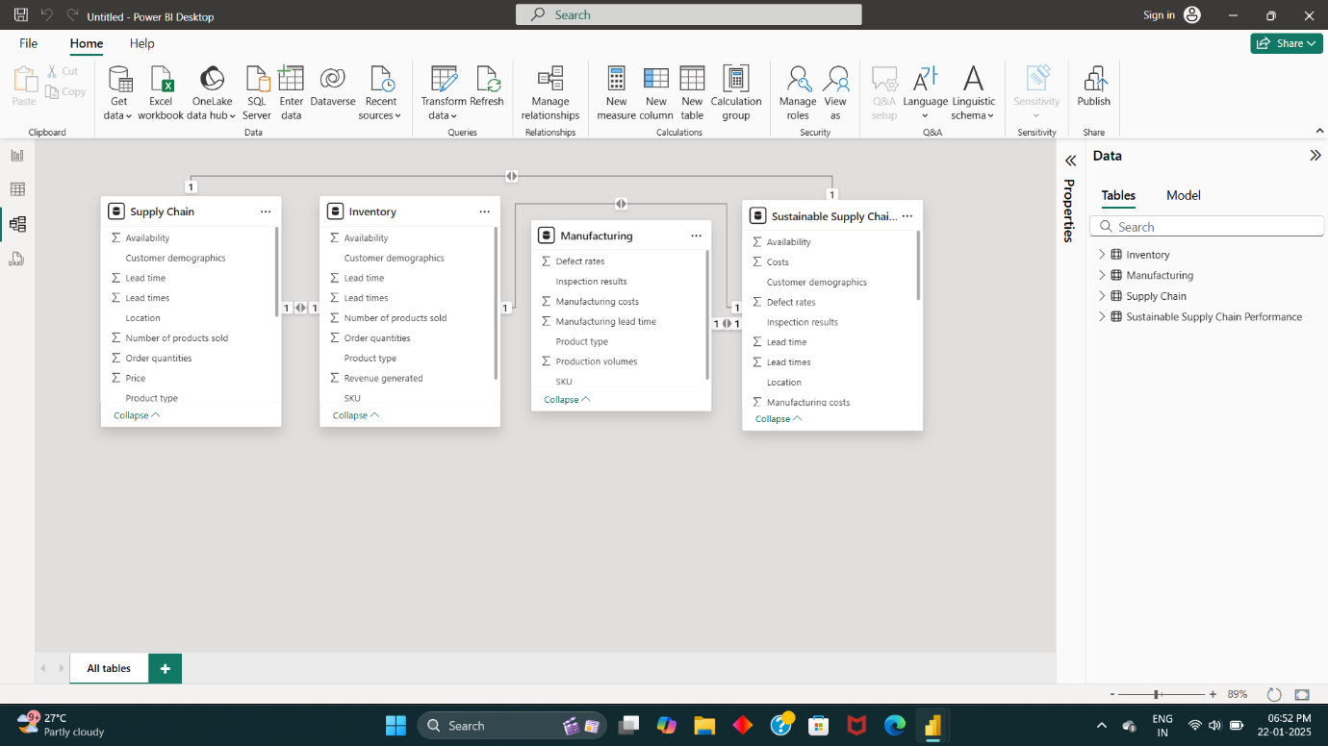

* Thus, the table data is ready to Analysis of Sustainable Supply Chain Performance Dashboard using Power BI.